175

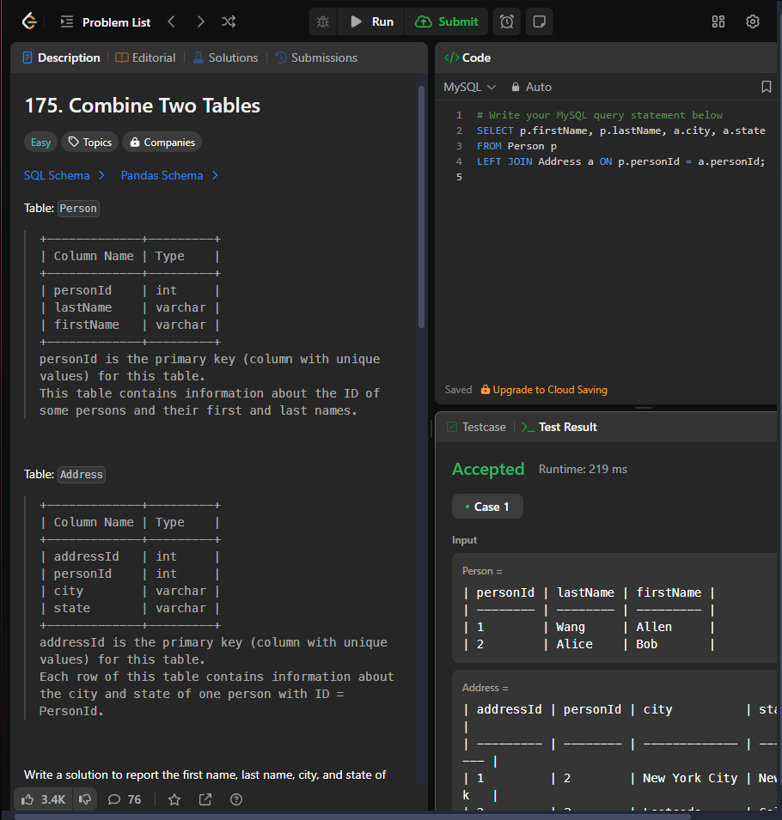

176

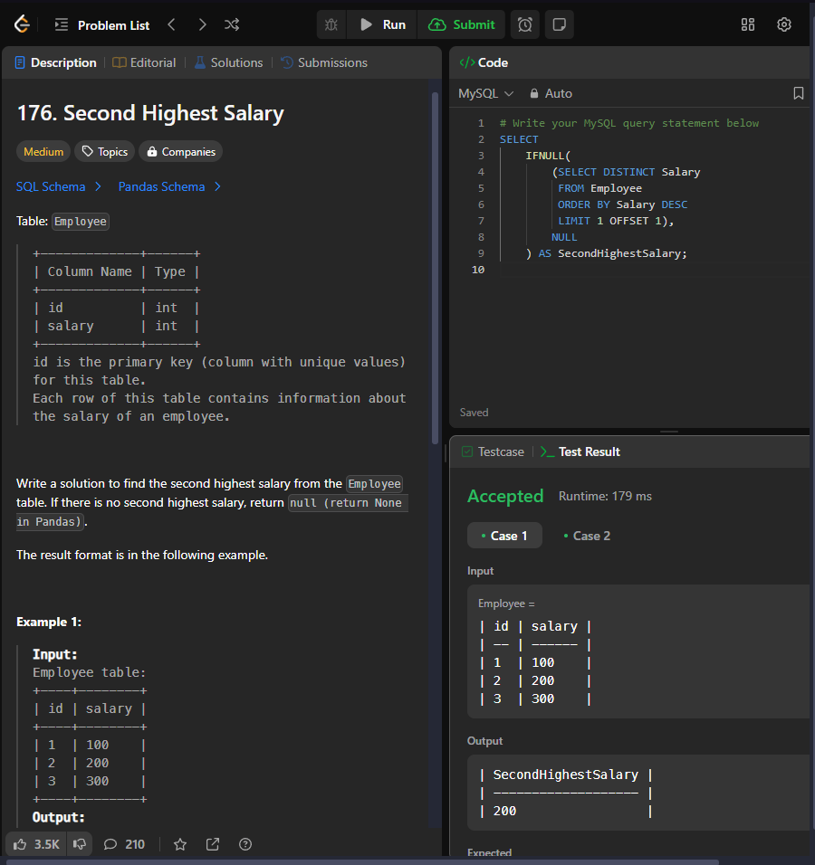

177

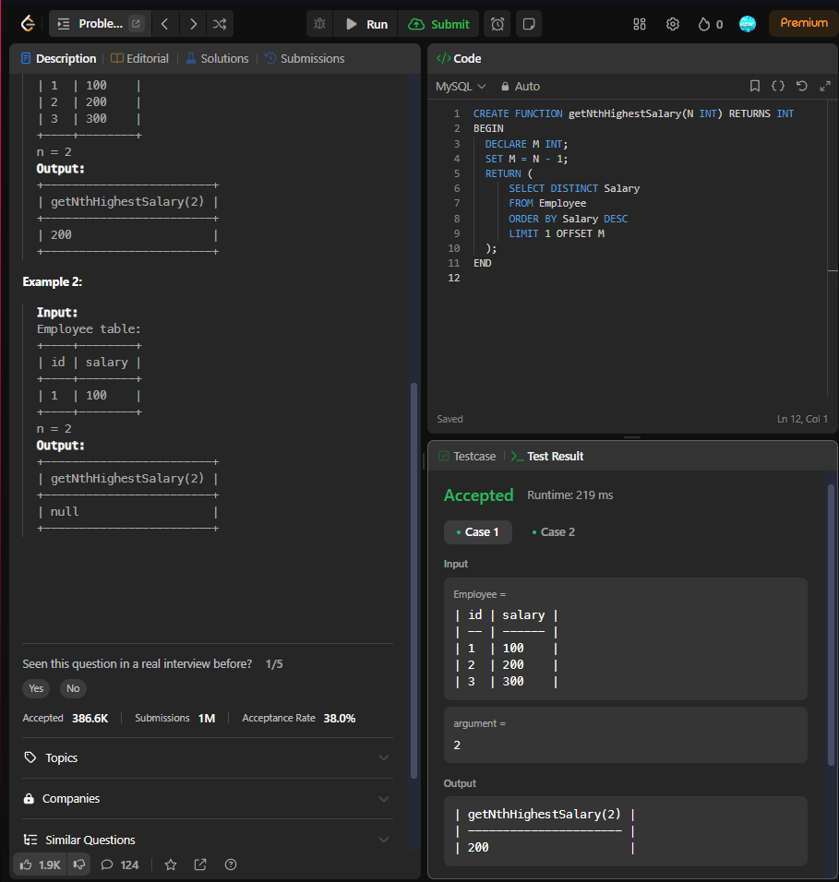

181

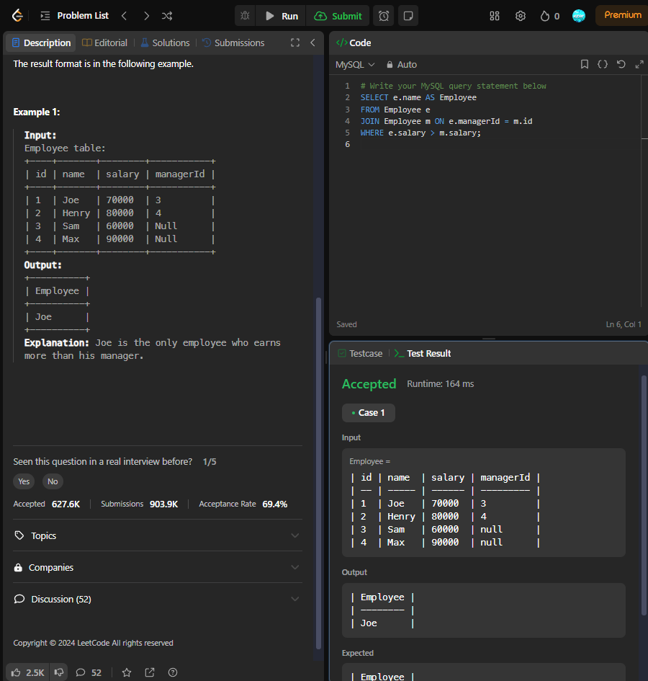

182

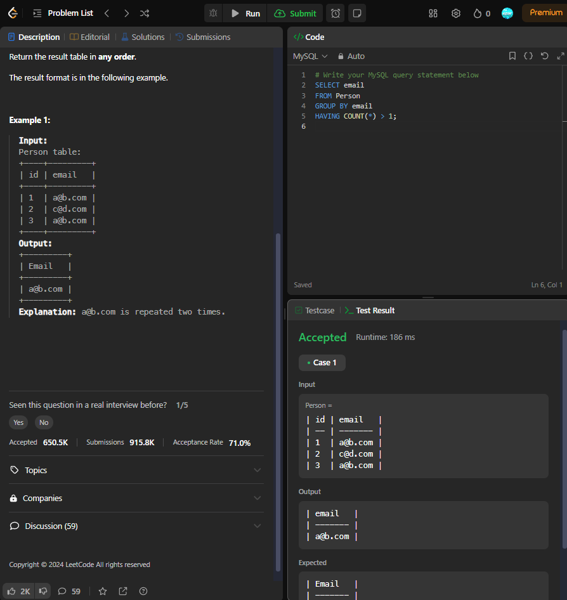

183

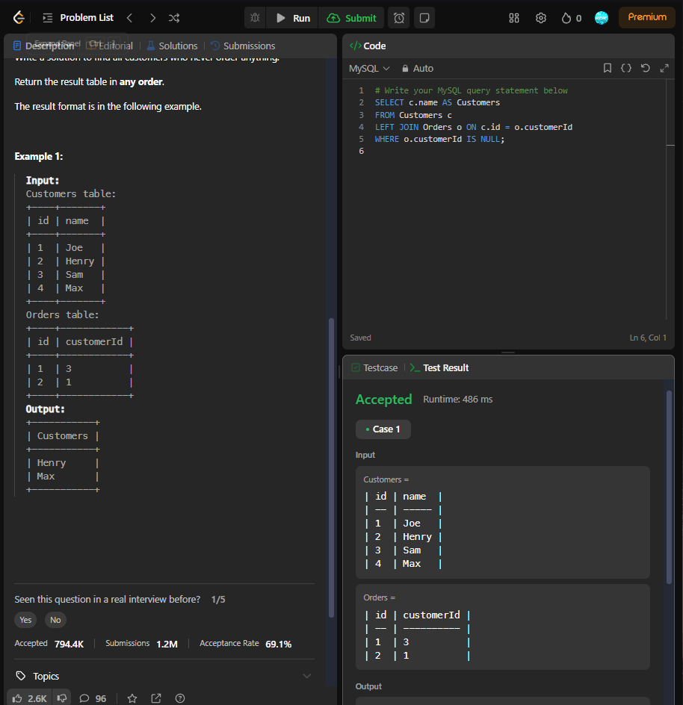

184

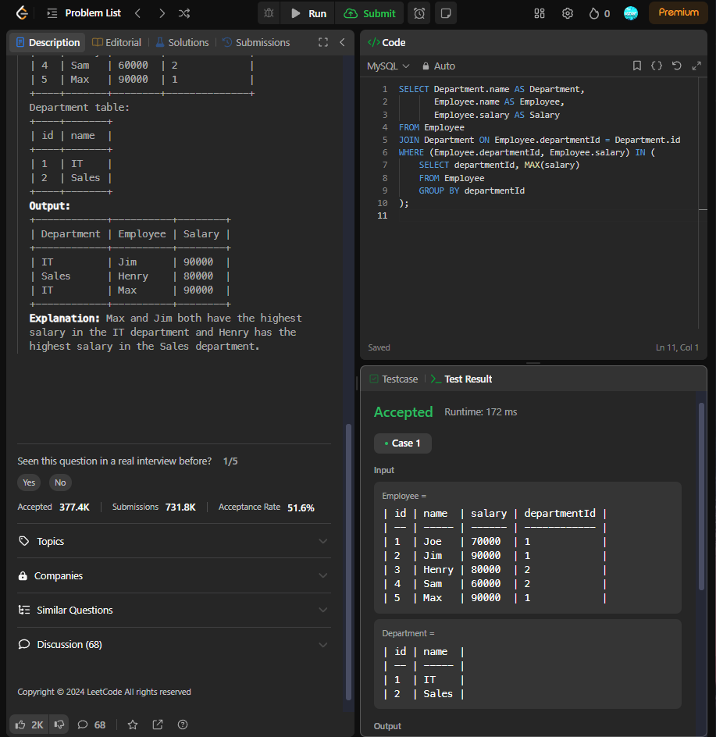

196

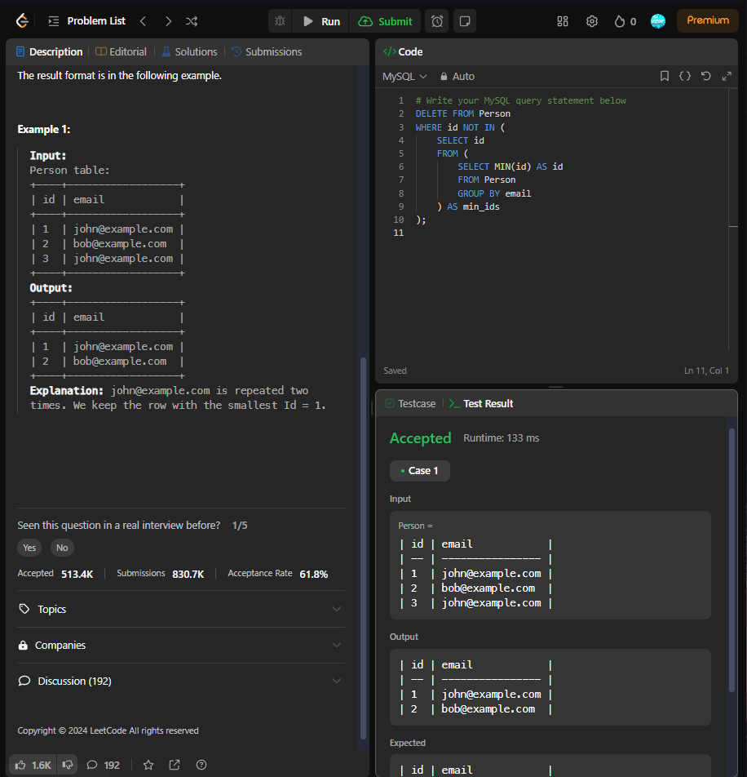

197

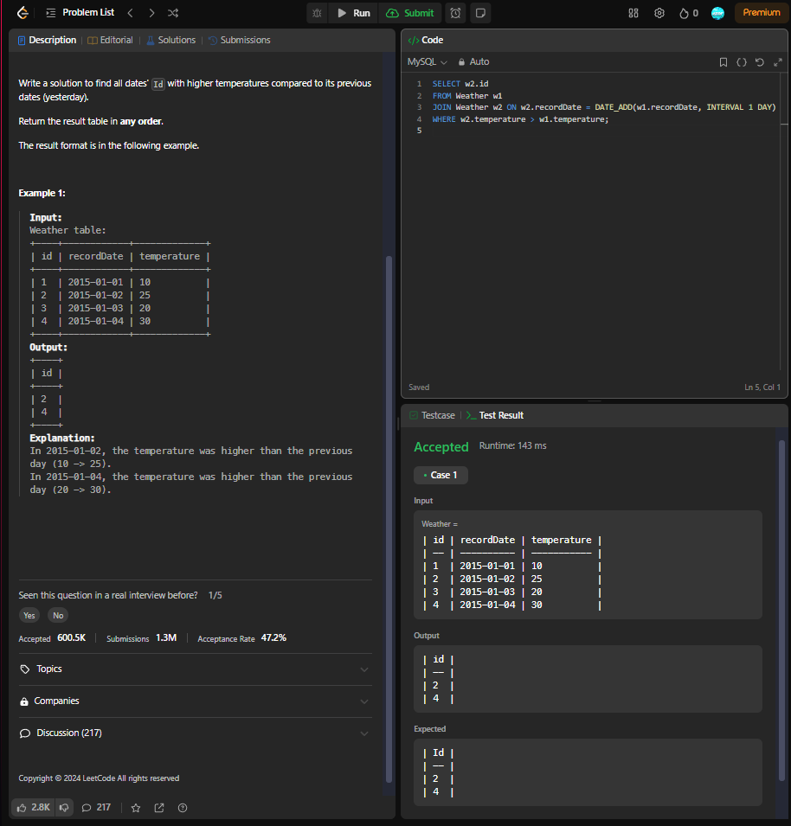

262

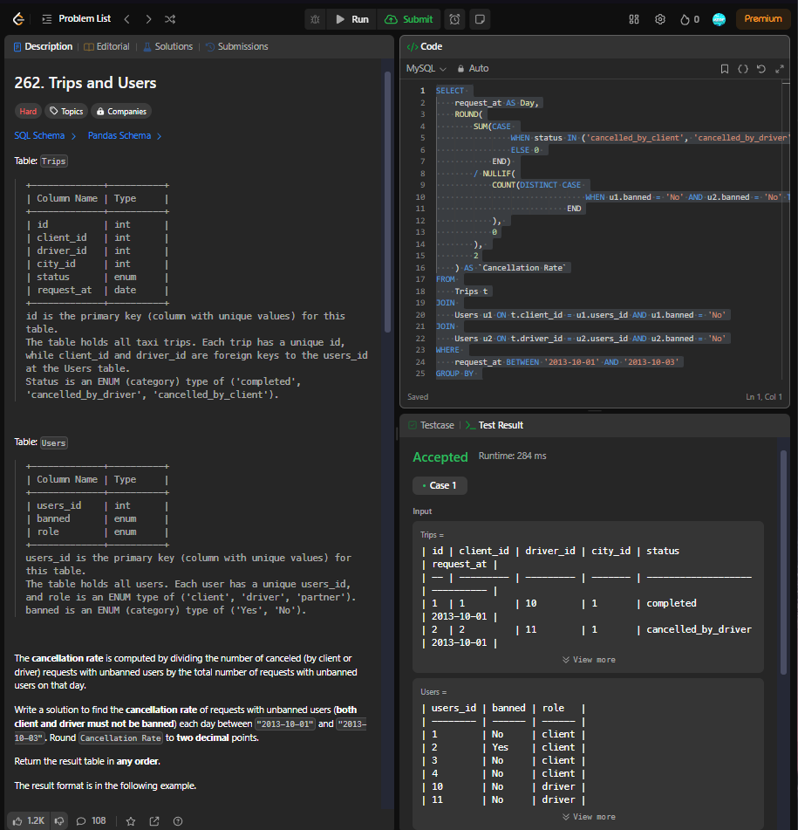

SELECT

    request_at AS Day,

    ROUND(

        SUM(CASE

                WHEN status IN ('cancelled_by_client', 'cancelled_by_driver') THEN 1

                ELSE 0

            END)

        / NULLIF(

            COUNT(DISTINCT CASE

                                WHEN u1.banned = 'No' AND u2.banned = 'No' THEN t.id

                            END

            ),

            0

        ),

        2

    ) AS `Cancellation Rate`

FROM

    Trips t

JOIN

    Users u1 ON t.client_id = u1.users_id AND u1.banned = 'No'

JOIN

    Users u2 ON t.driver_id = u2.users_id AND u2.banned = 'No'

WHERE

    request_at BETWEEN '2013-10-01' AND '2013-10-03'

GROUP BY

    request_at;

511

